User Manual:

If you want to book a hotel room its really simple, just fill in the form that looks like this:

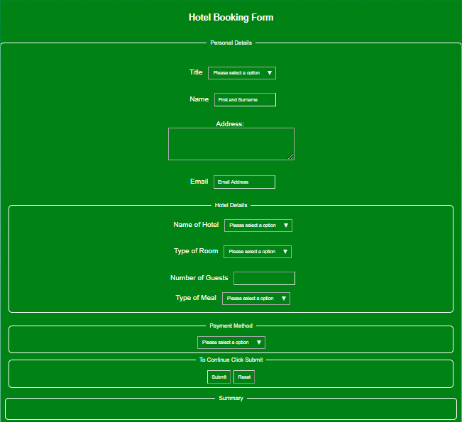

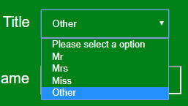Firstly, select your title. If you don’t choose this the form will not display this option when the form is submitted.

The Next Step is to enter your name, if you don’t enter this the form will not submit.



In the Address section, its important to enter all address information including the postcode.

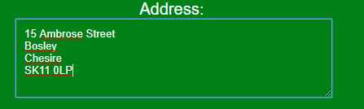

The Email section is required to send a confirmation email to you so you have a record of the booking.



The Hotel option is mandatory, without an option being selected the booking will not submit.

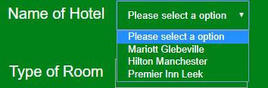

The room option is also mandatory. Choosing one of these options will determine the price you will pay overall.

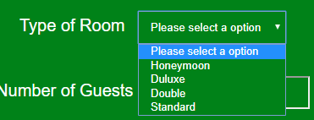

The Number of Guests is needed to help determine if you are eligible for a discount. If you are booking for more than 6 guests you will be eligible for 10% and more than 10 would incur a 15% discount.



You will also have the option to have food at the hotel you choose. Select what option you would like and it will feed back in the summary.

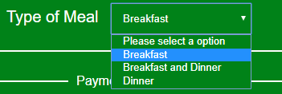

Finally, select your payment method. This will either advise the hotel you are paying cash or take you to a payment section to submit your card details.

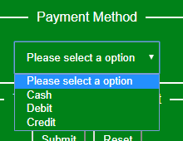

Once this has been filled in click submit and then a summary will appear at the bottom of the page it should look like this.

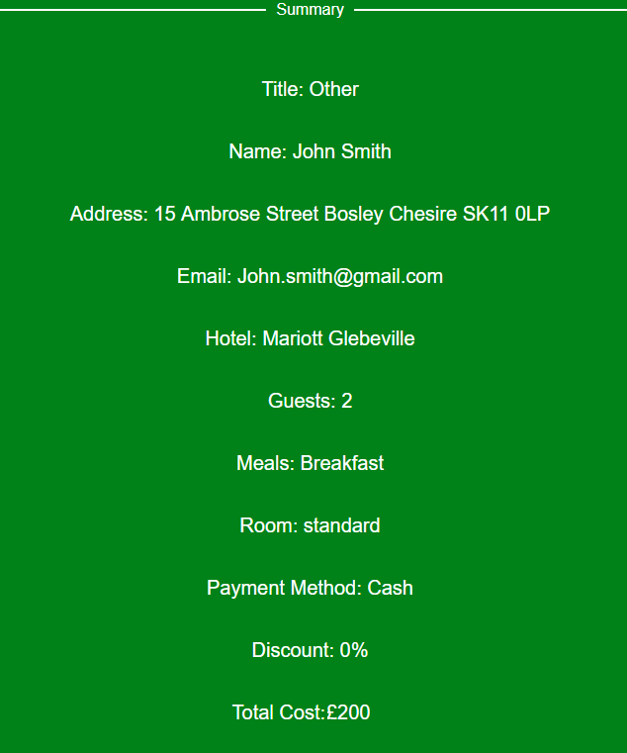

If you make a mistake on the form just click reset and the form will go back to the beginning.